UNCG

**System Requirements Document**

**Digital Billboard**

Abstract

The Digital Billboard streams up-to-date web content based on the system configuration to access web sources.   
Other sources of information can be added.

Author

Charles Brady, System Analyst

Table of Contents

1 Introduction 1

1.1 System Description 1

1.2 Goals and Objectives 1

1.3 System Features 1

2 Functional Requirements 1

2.1 Use Cases 1

2.1.1 Normal Use Case 1

2.1.2 Error Use Case 2

2.2 Requirements 3

2.3 External Interface Requirements 3

2.3.1 User Interface Requirements 3

2.3.2 Software Interface Requirements 3

2.3.3 Hardware Interface Requirements 4

2.3.4 Communication Protocols for Interfaces 4

3 Non-Functional Requirements 4

3.1 Infrastructure Requirements 4

3.2 Performance Requirements 4

3.3 Security Requirements 4

3.4 Availability Requirements 4

3.5 Reliability Requirements 4

3.6 Scalability Requirements 5

3.7 Maintainability Requirements 5

3.8 Backup / Disaster Recovery Requirements 5

3.9 Demographic Requirements 5

3.10 Training Requirements 5

4 Reviewers 5

5 Appendix 6

5.1 Revision History 6

5.2 Reference Documents 6

# Introduction

## System Description

The Digital Billboard streams up-to-date web content based on the system configuration to access web sources. Other sources of information can be added via the administration module.

## Goals and Objectives

Display the following information on the Digital Billboard:

* Title or caption, date and image from news post
* Title or caption, date and text from Instagram® source
* Title and video from YouTube® channel source

## System Features

* Administration Module to allow adding, deleting, and selecting the source of web content to be displayed
* Display that simulates Digital Signage technology

# Functional Requirements

## Use Cases

### Normal Use Case

The normal Use Case includes 2 actors: The Viewer and the Administrator.

The Viewer has one action, to view the Digital Billboard. A source must have been selected by the Administrator, and the system must be running to allow this use case.

The Administrator has three actions:

* Select the source to be displayed
* Add a source
* Delete a source

The normal Use Case diagram is provided below.

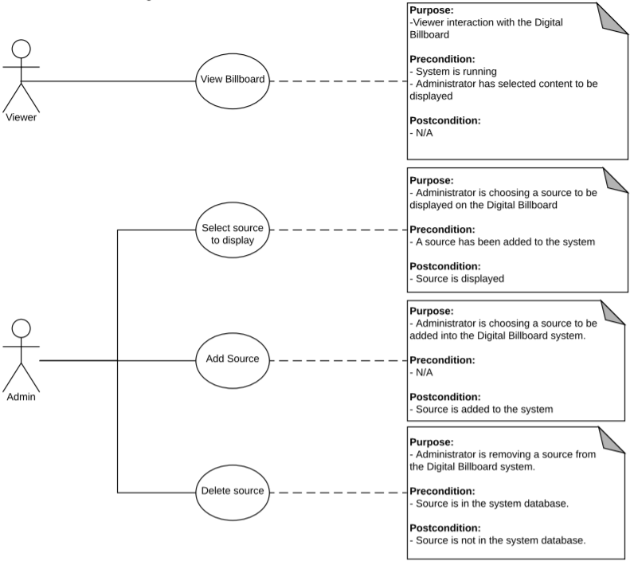

### Error Use Case

The error Use Case includes 2 actors: The Viewer and the Administrator.

The Viewer has one action (Redirect), to view the Digital Billboard. When the URL selected to be displayed is not available, a default URL is displayed via a Redirect. The Viewer is unaware that an error occurred.

The Administrator has one action (Controller Error), which displays an error message if there is an issue with changing the displayed content.

The error Use Case diagram is provided below.

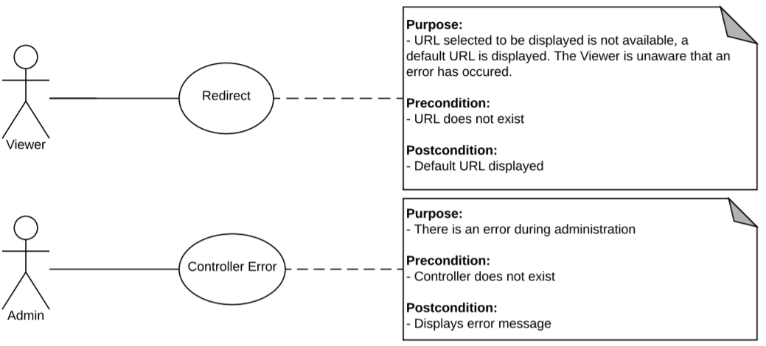

## Requirements

| ID | Requirement Description | Priority |
| --- | --- | --- |
|  | Display content from news posts, Instagram®, and YouTube® channel in a Digital Signage format | High |
|  | If the selected content URL is invalid, redirect to a default URL | High |
|  | Allow the administrator to select the content to be displayed | High |
|  | Allow the administrator to add a content source | High |
|  | Allow the administrator to delete a content source | Low |
|  |  |  |

## External Interface Requirements

### User Interface Requirements

| ID | Requirement Description | Priority |
| --- | --- | --- |
|  | Billboard that displays content | High |

### Software Interface Requirements

| ID | Requirement Description | Priority |
| --- | --- | --- |
|  | Web-based news post | High |
|  | Instagram® | High |
|  | YouTube® | High |

### Hardware Interface Requirements

| ID | Requirement Description | Priority |
| --- | --- | --- |
|  | Billboard, which can be any device that displays a web page. | High |

### Communication Protocols for Interfaces

| ID | Requirement Description | Priority |
| --- | --- | --- |
|  | HTTP to access available content | High |

# Non-Functional Requirements

## Infrastructure Requirements

| ID | Requirement Description | Priority |
| --- | --- | --- |
|  | Device that can display web content and serves as Digital Billboard | High |

## Scalability Requirements

| ID | Requirement Description | Priority |
| --- | --- | --- |
|  | System will have the ability to add other content in the future, but adding content will require code changes. | High |

## Maintainability Requirements

| ID | Requirement Description | Priority |
| --- | --- | --- |
|  | System must allow additional web sources from news posts, Instagram®, and YouTube® to be added | High |

## Demographic Requirements

| ID | User Type | Device Type | Location | Usage | # Users |
| --- | --- | --- | --- | --- | --- |
|  | Viewers | Billboard | Anywhere | View the displayed content | Unlimited |

# Reviewers

|  |  |
| --- | --- |
| Name | Position |
| Mikael Williams | Team Lead |
| Michael McCulloch | Developer |
| Jacob Oleson | Developer |

# Appendix

## Revision History

|  |  |  |  |
| --- | --- | --- | --- |
| Version # | Date of Change | Summary of Change | Author |
| 0.1 | 10/20/2018 | Initial Version | Charles Brady |
| 1.0 | 10/31/2018 | Incorporate Team Comments | Charles Brady |
| 1.1 | 12/4/2018 | Incorporate Team Comments | Charles Brady |

## Reference Documents

Use Case Diagrams are provided in this document and as a separate document.